Student Name : Santosh Acharya

Student Id : c0930325

Program Code: CSD 2206

Assignment 2

Question of assignment

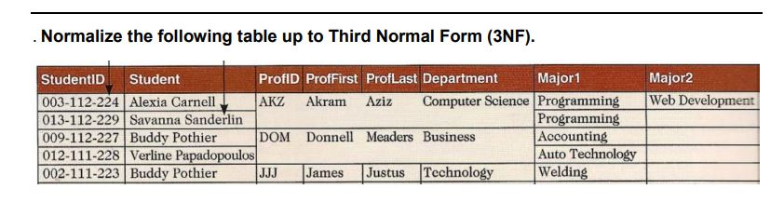

* Note:
  + PK-> Primary Key
  + FK -> Foreign Key

**First Normal Form / 1NF**

**Requirement / criteria for 1st Normal Form**

* The 1st Normal Form is performed to remove the repeating group, or multivalued columns.

**Table complete the below criteria to be 1NF**

* Major 1, Major 2 is repeating group so it is converted to Major.
* So, the table has been converted to 1NF.
* **Students(Student_Id , Prof_Id,** Student, Prof_First, Prof_Last, Department, Major**)**
* **Student_Id** and **Prof_Id is** composite primary key.

Composite Primary Key

**Students**

|  |  |  |  |  |  |  |
| --- | --- | --- | --- | --- | --- | --- |
| **Student_Id** | **Prof_Id** | Student | Prof_First | Prof_Last | Department | Major |
| 0003-112-224 | AKZ | Alexia Carnell | Akram | Aziz | Computer Science | Programming |
| 0003-112-224 | AKZ | Alexia Carnell | Akram | Aziz | Computer Science | Web Development |
| 013-112-229 | AKZ | Savanna Sanderlin | Akram | Aziz | Computer Science | Programming |
| 009-112-227 | DOM | Buddy Pothier | Donnell | Meaders | Business | Accounting |
| 012-111-228 | DOM | Verline Papadopoulos | Donnell | Meaders | Business | Auto Technology |
| 002-111-223 | JJJ | Buddy Pothier | James | Justus | Technology | Welding |

**Second Normal Form / 2NF**

**Requirement / criteria for 2nd Normal Form**

* The table must be in 1NF
* The 2nd Normal Form is performed when there is composite primary key and partial dependencies.

**Table complete the below criteria to be 2NF**

* Table is already in 1NF.
* There is partial dependency between Student_Id and Prof_Id in 1NF table which has been eliminated in 2NF
* **Students**(**Student_Id**, Student)
* **Professor**(**Prof_id**, Prof_First, Prof_Last,Department)
* **Student_Major**(**Student_Id**, **Prof_id**, Major)

Student_id (FK, PK)->Student_Major

Prof_Id (FK,PK)->Student_major

Primary Key

**Students**

|  |  |
| --- | --- |
| **Student_Id** | Student |
| 0003-112-224 | Alexia Carnell |
| 013-112-229 | Savanna Sanderlin |
| 009-112-227 | Buddy Pothier |
| 012-111-228 | Verline Papadopoulos |
| 002-111-223 | Buddy Pothier |

Primary Key

**Professor**

|  |  |  |  |
| --- | --- | --- | --- |
| **Prof_Id** | Prof_First | Prof_Last | Department |
| AKZ | Akram | Aziz | Computer Science |
| DOM | Donnell | Meaders | Business |
| JJJ | James | Justus | Technology |

**Student_Major**

Primary Key, Foreign Key

|  |  |  |
| --- | --- | --- |
| **Student_Id** | **Prof_Id** | Major |
| 003-112-224 | AKZ | Programming |
| 0003-112-224 | AKZ | Web Development |
| 013-112-229 | AKZ | Programming |
| 009-112-227 | DOM | Accounting |
| 012-111-228 | DOM | Auto Technology |
| 002-111-223 | JJJ | Welding |

**Third Normal Form / 3NF**

**Requirement / criteria for 3rd Normal Form**

* The table must be in 2nd Normal Form to be converted into 3NF
* The table should not contain non-key dependencies.

**Table complete the below criteria to be 2NF**

* Since table already is in 2NF and table doesn’t have contain non-key dependencies in 2NF table. Therefore, the 2NF table is appear to 3NF table also.

**Students**

|  |  |
| --- | --- |
| **Student_Id** | Student |
| 0003-112-224 | Alexia Carnell |
| 013-112-229 | Savanna Sanderlin |
| 009-112-227 | Buddy Pothier |
| 012-111-228 | Verline Papadopoulos |
| 002-111-223 | Buddy Pothier |

**Professor**

|  |  |  |  |
| --- | --- | --- | --- |
| **Prof_Id** | Prof_First | Prof_Last | Department |
| AKZ | Akram | Aziz | Computer Science |
| DOM | Donnell | Meaders | Business |
| JJJ | James | Justus | Technology |

**Student_Major**

|  |  |  |
| --- | --- | --- |
| **Student_Id** | **Prof_Id** | Major |
| 003-112-224 | AKZ | Programming |
| 0003-112-224 | AKZ | Web Development |
| 013-112-229 | AKZ | Programming |
| 009-112-227 | DOM | Accounting |
| 012-111-228 | DOM | Auto Technology |
| 002-111-223 | JJJ | Welding |

Whereas the table has completed the requirement for 3NF in 2NF it is consider good normalization because it will reduce data redundancy and reduce the data retrieving time from the database